Fluency Instructions 4 Mentors

- Give the student a copy of the Fluency Passage. Always use a fluency passage.
- Mark errors with a slash ( / ) on the mentor’s fluency passage.
- Only mark errors on the mentor’s fluency passage for the cold, warm and hot reads.

One Minute COLD READ: BLUE

When a student is given a new book (Level F and above), the student is given a fluency passage that he/she has not read. The student will do a COLD read for ONE MINUTE and graph it in BLUE.

When needed, the mentor will tell the student: “Do you know how we become better at hitting a baseball or kicking a soccer ball or baking a cake? We have to practice doing it; usually many times. The more we practice, the better we become. Learning to read is the same. Every one of us has to practice to read better. Each time you are given a new book; there will be three timed readings. You have a graph to fill in the number of words you read correctly. This will help you to see just how your reading is improving.”

Point to the first word (student will not read titles) and say: “Please read this out loud. If you get stuck on a word (struggling for more than 3 seconds) I will tell you the word so you can keep reading until I say stop.”

Start the stopwatch when the student reads the first word.

After one minute say, “STOP” and place a bracket ] after the last word read. Subtract the number of errors (see Directions for Scoring) from the total words read to get the correct words per minute (wpm). The mentor fills in the date, title of book, wpm, on the student’s graph. The student will graph/color the number of words read correctly in BLUE.

Practice and One Minute WARM READ: YELLOW

During the same lesson, the mentor reads the ENTIRE fluency passage to the student. The mentor reads a bit faster and with expression; hence, more fluently than the student just read. This gives the student a good model for reading. Now have the student Practice reading the passage aloud, helping with words missed.

Next the student does the WARM read for ONE MINUTE and graphs the wpm in YELLOW. The student likes graphing his/her immediate improvement.

During the following sessions (could be 2,3,4…) continue doing the Comprehension Lessons and practice the fluency passage.

One Minute HOT READ: RED

During the last session of the comprehension pack, have the student practice reading the fluency passage, and then do the HOT read for ONE MINUTE and graph it in RED.

www.M4RA.org 25
Directions for Scoring

During the independent fluency reading, resist the urge to correct mistakes. Mistakes and self-correction will be counted in the score. If the student has extreme difficulty, stop the fluency test. Write a note to the coordinator that the fluency passage was too difficult.
32
-4
28

45
-2 errors
43

57
-2 errors
55
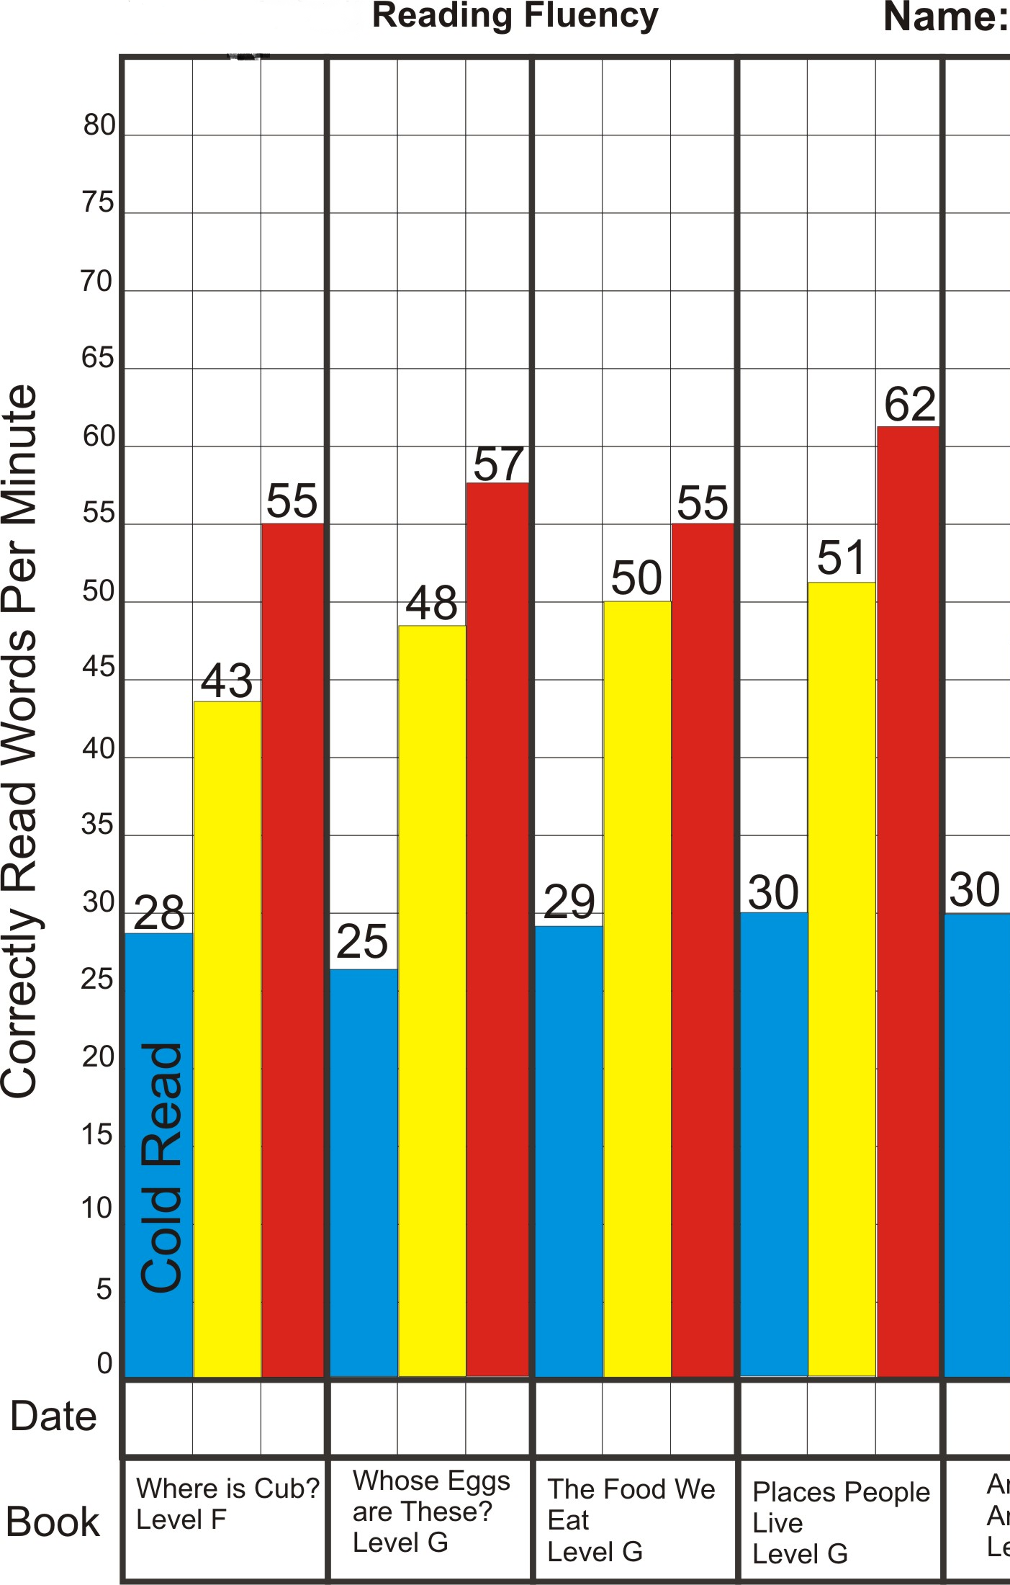
Errors Include:
errors
- Skipped words
- Mispronounced words
- Word substitutions, including incorrect forms of the word
- Words in the wrong order; both or all words are counted as wrong
- Struggling that lasts for 3 seconds or more

The following are not considered errors:
- Added words
- Varying pronunciation due to accent, dialect, or speech impediment
- Repetitions in which the wording is correct
- Self-correcting a mistake; the word is scored as correct

www.M4RA.org 26

